Draft write-up

This document provides an overview of demographic changes in the Delaware Valley region from 1990 to 2017. The content of this document currently includes charts showing the change in variables from 1990 to 2017 at the county and regional level, maps showing the difference in variables from 1990 to 2017 at the neighborhood level, and indices that give us snapshots of the ways variables are changing over time.

Each type of information has a unique purpose. Charts provide a view of temporal change that maps cannot communicate. However, these charts must be aggregated to the county or regional level, and data aggregated to the county or regional level obscure drastic differences at the neighborhood level. This is where maps come in: they allow us to dig into change at a granular level. Lastly, the indices used here capture segregation and inequality in a way the human eye cannot.

When we combine these three types of information, we equip ourselves with the means to visualize broad trends, to delve into neighborhood-level changes, and to quantify changes in segregation and inequality over time.

Top-line findings so far:

1. Population is growing throughout the Delaware Valley region.
2. Economic inequality is growing in the region.
3. The region is becoming more racially and ethnically diverse and less segregated.
4. The percentage of low-income residents is on the rise.
5. Low-income residents live increasingly farther from Center City Philadelphia.
6. Home values are increasing in transit-accessible suburbs and in some Philadelphia neighborhoods.
7. Homeownership is falling rapidly in Philadelphia.

# Population is growing throughout the Delaware Valley region.

Montgomery and Chester counties in Philadelphia have seen faster rates of growth than the rest of the region. Though Philadelphia’s population decreased from 1990 to 2000, it is on the rise again.

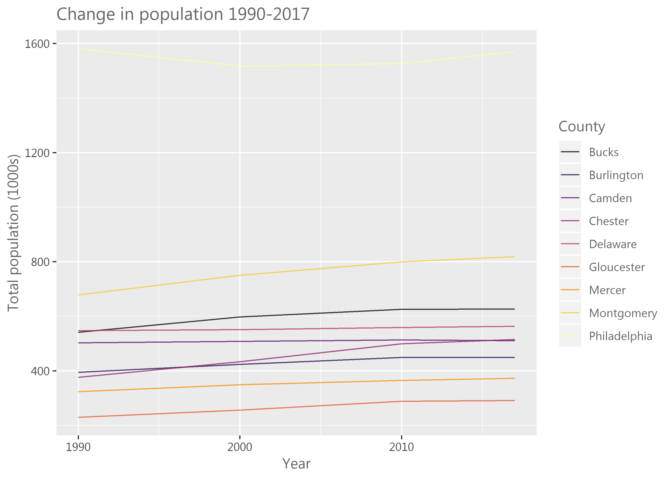

Some townships, boroughs, and neighborhoods in the region have seen population growth far outpacing the region as a whole. In Pennsylvania, these areas include Center City, University City, Old City, Northern Liberties, and Fitler Square in Philadelphia; Concord and Bethel Townships in Delaware County; Limerick, Skippack, Upper Providence, Worcester, and Montgomery Townships in Montgomery County; London Grove Township and the surrounds of Coatesville in Chester County; and Warrington, Warwick, and Buckingham Townships in Bucks County. In New Jersey, these areas include parts of Gloucester Township in Camden County; Woolwich, Harrison, East Greenwich, and parts of Deptford Townships in Gloucester County; East and West Windsor Townships in Mercer County; and Fieldsboro Borough and Bordentown and Mansfield Townships in Burlington County.

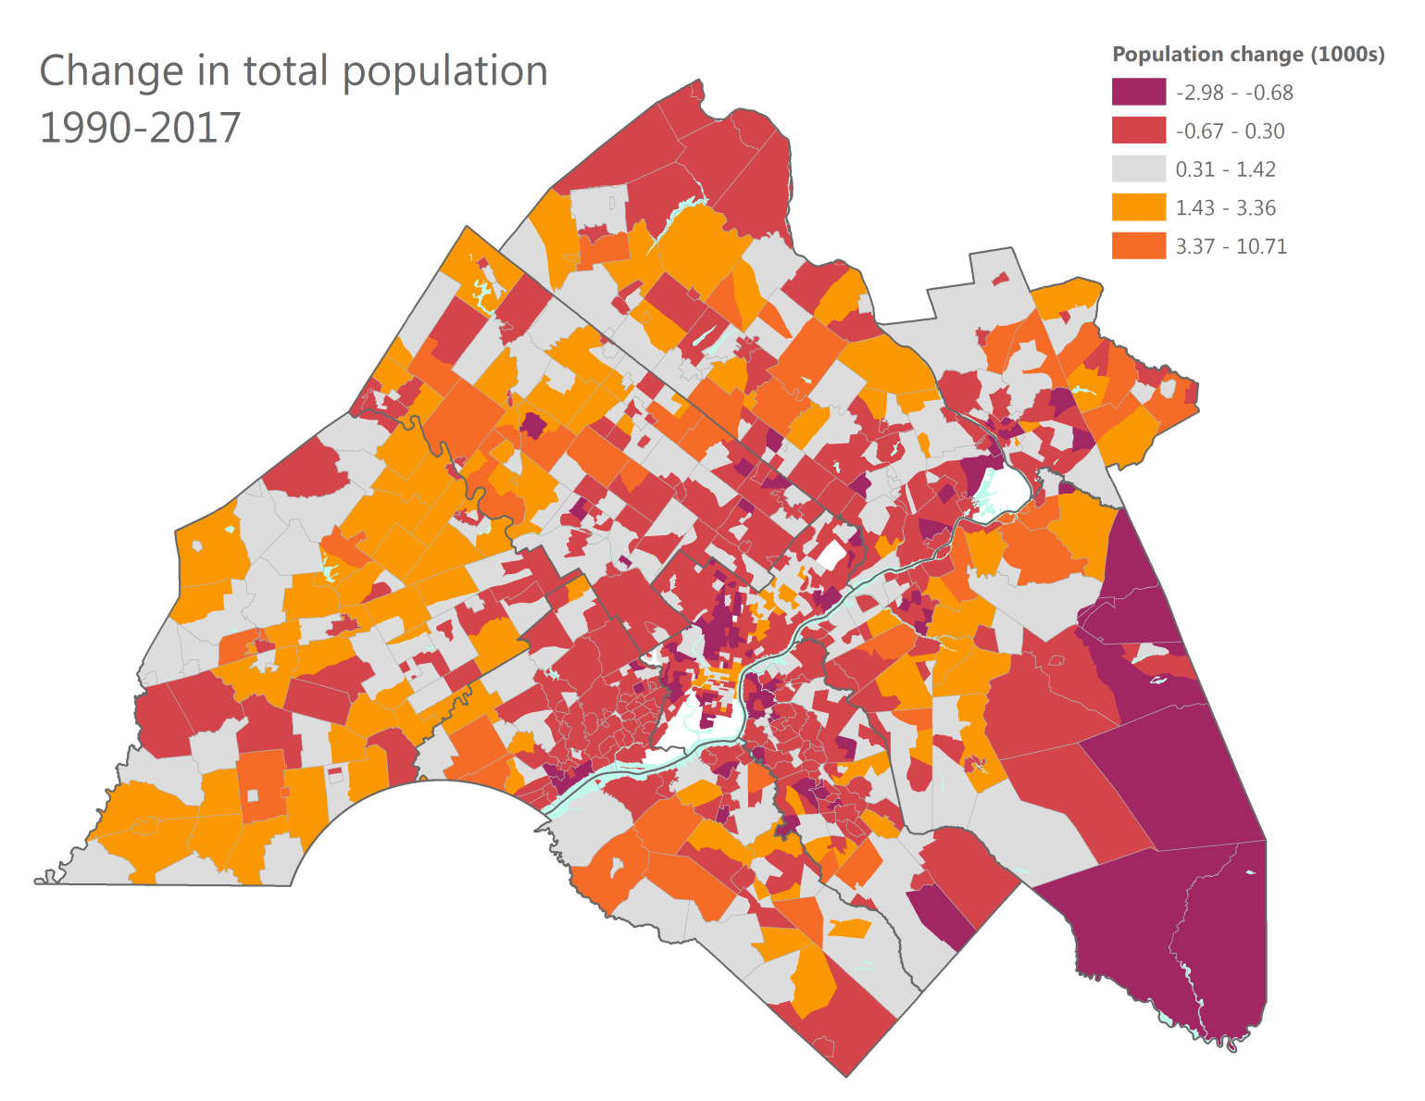

# Economic inequality is growing in the region.

The Theil index of economic inequality indicates that the region’s economic inequality has increased since 1990. These numbers indicate one or both of the following trends: 1) some neighborhoods are “pulling away” with increasingly high household incomes; 2) some neighborhoods are “pulling away” with steadily declining household incomes. Either way, the result is spatial segregation of residents based on their incomes.

|  |  |
| --- | --- |
| Year | Theil inequality index – Median household income |
| 1990 | 0.068 |
| 2000 | 0.113 |
| 2010 | 0.145 |
| 2017 | 0.147 |

# The region is becoming more racially and ethnically diverse and less segregated.

The Delaware Valley region has become more racially and ethnically diverse and less spatially segregated from 1990 to 2017. At the same time, we’ve seen large declines in ethnic and racial diversity in central Philadelphia, Camden, and Trenton.

Philadelphia, Camden, and Mercer counties have historically been and continue to be more racially and ethnically diverse than the region overall. All counties have become more racially and ethnically diverse from 1990 to 2017.

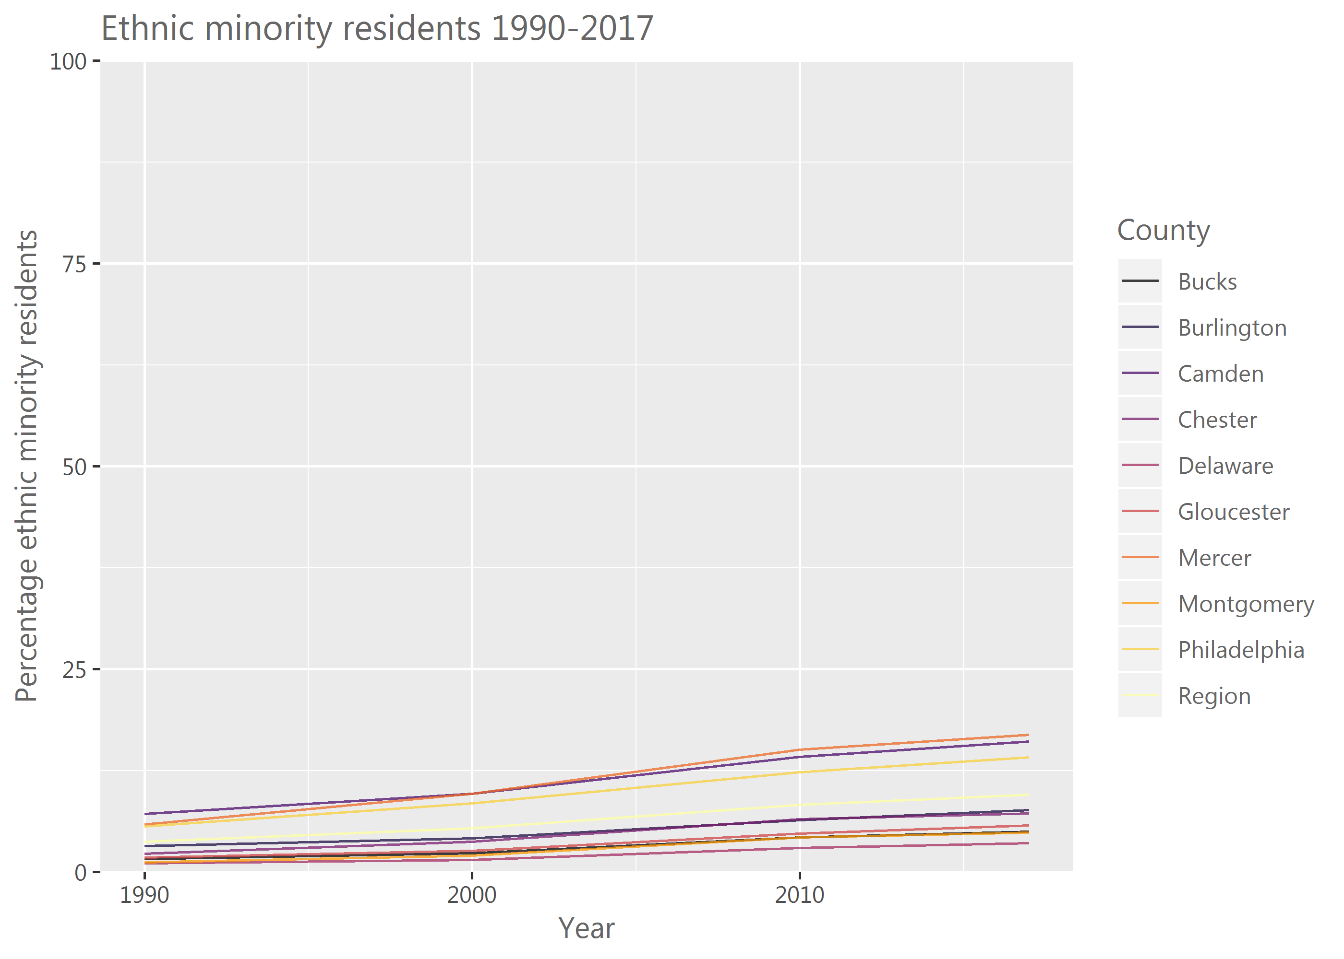

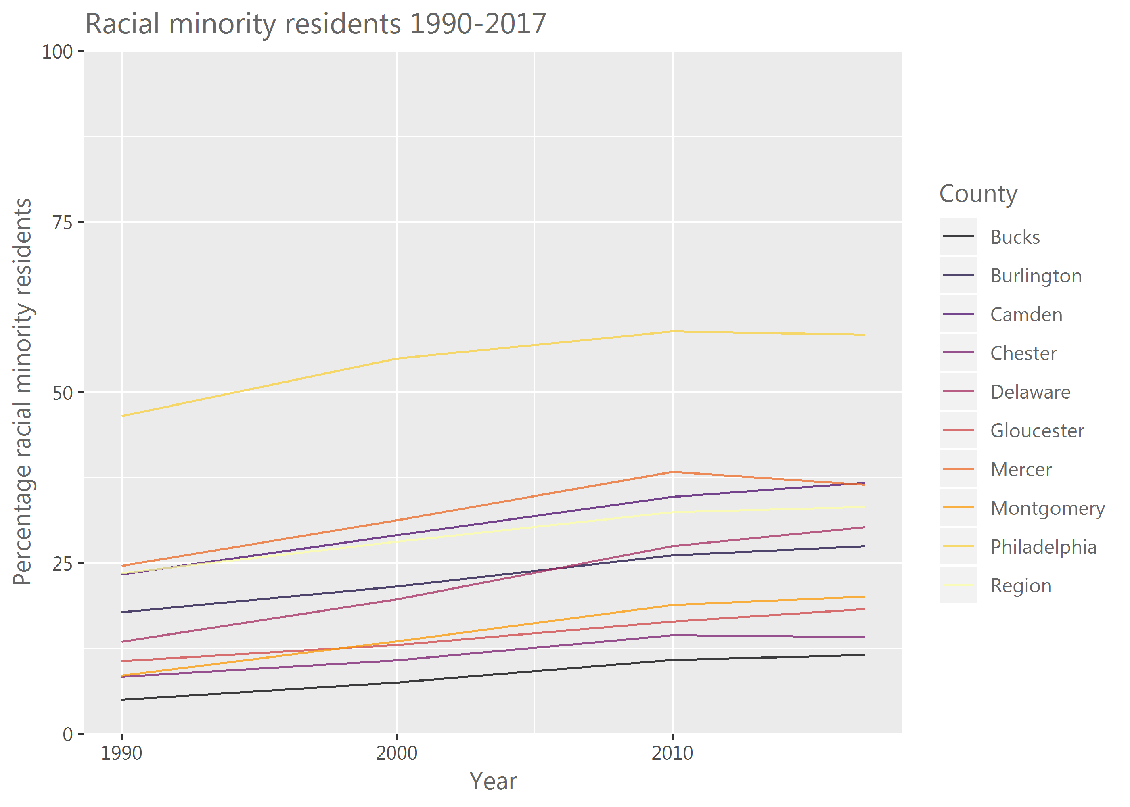

Areas that have seen an increase in racial minority residents in Pennsylvania include North Philadelphia and the Juniata Park and Frankford neighborhoods; Upper Darby in Delaware County; Hatfield, Cheltenham, Upper Merion, East and West Norriton Townships in Montgomery County; and Coatesville in Chester County. In New Jersey, these areas include Pennsauken Township, Woodlynne Borough, and parts of Camden in Camden County; West Trenton and Hamilton Township in Mercer County; and Mansfield and Burlington Townships in Burlington County.

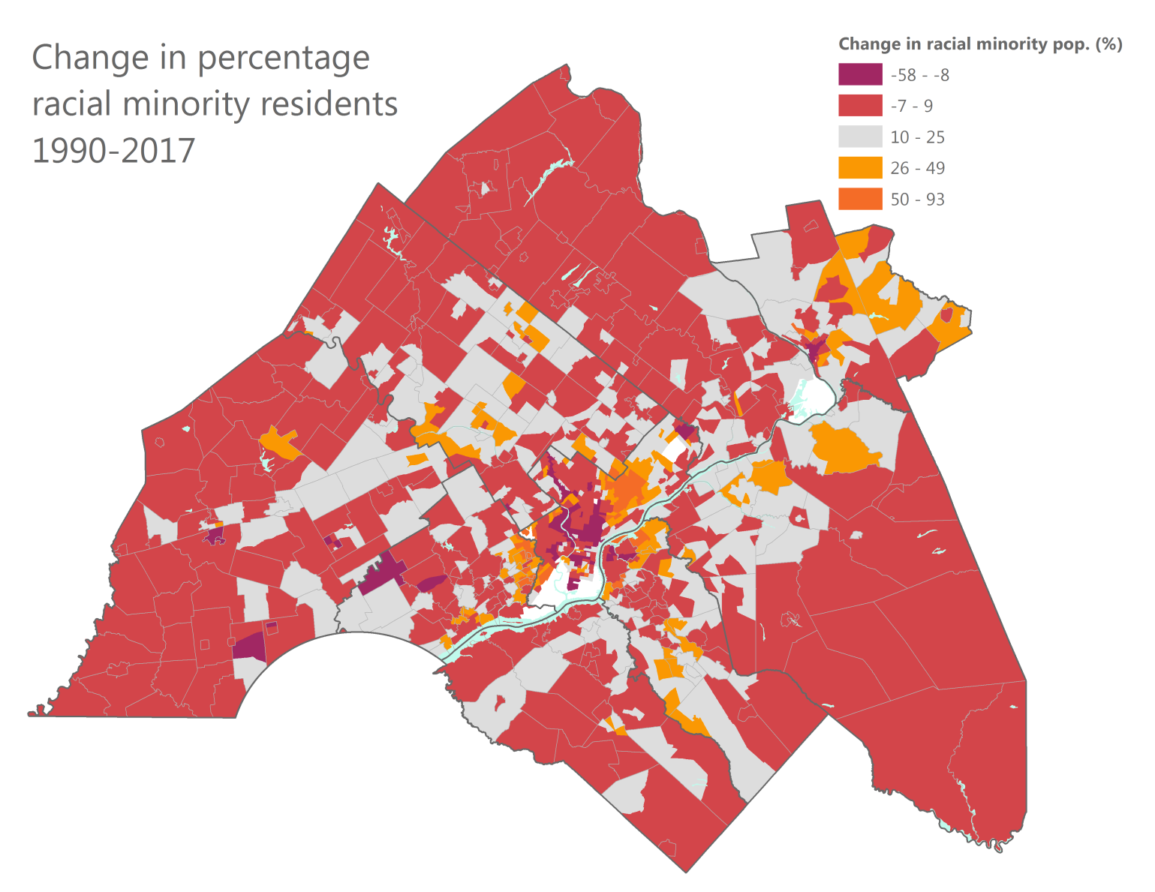

Areas that have seen an increase in ethnic minority residents include North and Northeast Philadelphia, especially around Juniata Park and Kensington; Norristown Borough in Montgomery County; Kennett Square, West Grove, and Oxford Boroughs in Chester County; and Bensalem Township in Bucks County. In New Jersey, these areas include Pennsauken Township, Gloucester City, and Woodlynne Borough in Camden County; and the Chambersburg neighborhood of Trenton and Hightstown Borough in Mercer County.

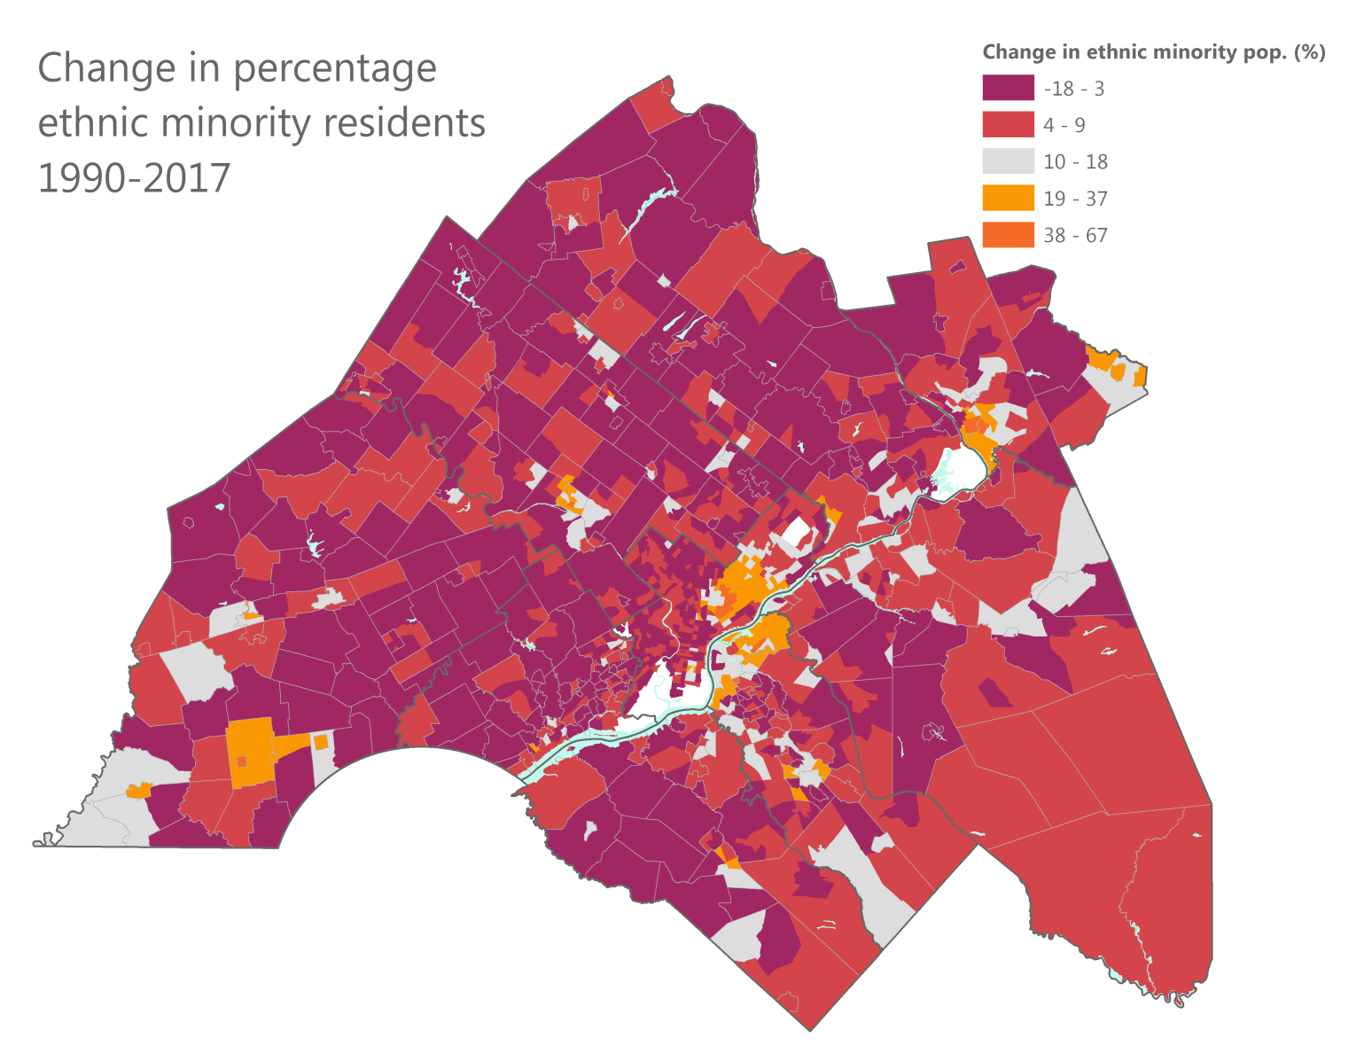

The dissimilarity index is a measure of the spatial evenness of a population and can range from 0 to 1, where smaller values mean greater spatial evenness. Indices of racial and ethnic dissimilarity have decreased in all years studied, indicating that the region is becoming less segregated over time.

|  |  |  |
| --- | --- | --- |
| Year | Index of dissimilarity – Racial minority | Index of dissimilarity – Ethnic minority |
| 1990 | 0.701 | 0.563 |
| 2000 | 0.62 | 0.536 |
| 2010 | 0.565 | 0.488 |
| 2017 | 0.532 | 0.486 |

# The percentage of low-income residents is on the rise.

The percentage of low-income residents has increased in the region as a whole. The rate of increase appears slower in Gloucester and Delaware Counties than the rest of the region.

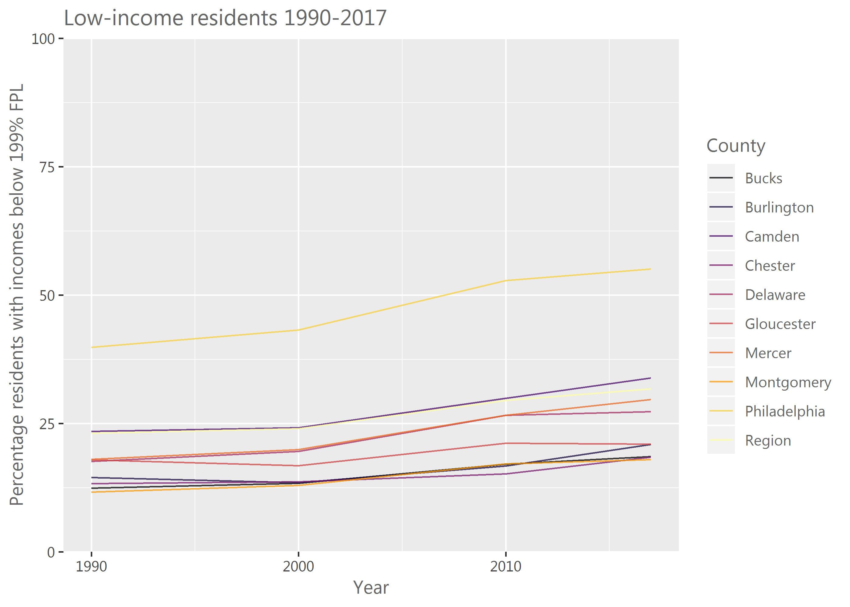

In Philadelphia, the percentage of low-income residents has increased substantially in most northern and northeastern neighborhoods. In the suburban Pennsylvania counties, Folcroft, Eddystone, Trainer, Millbourne, and parts of Collingdale and Colwyn Boroughs, as well as Yeadon and Darby and parts of Chester City in Delaware County; parts of Phoenixville and Coatesville Boroughs in Chester County; West Pottsgrove, West Norriton, Cheltenham, and Abington Townships and Pottstown, Royersford, and Norristown Boroughs in Montgomery County; and Bristol, Bensalem, and Bridgeton Townships in Bucks County have seen increases in the percentage of low-income residents. In New Jersey, these areas include Lindenwold and Bellmawr boroughs, Morgan Village and Bergen Square neighborhoods in Camden, and the northern part of Pennsauken Township in Camden County; Ewing and Hamilton Townships in Mercer County; and Edgewater Park, Willingboro, and Riverside Townships and Beverly and Palmyra Boroughs in Burlington County.

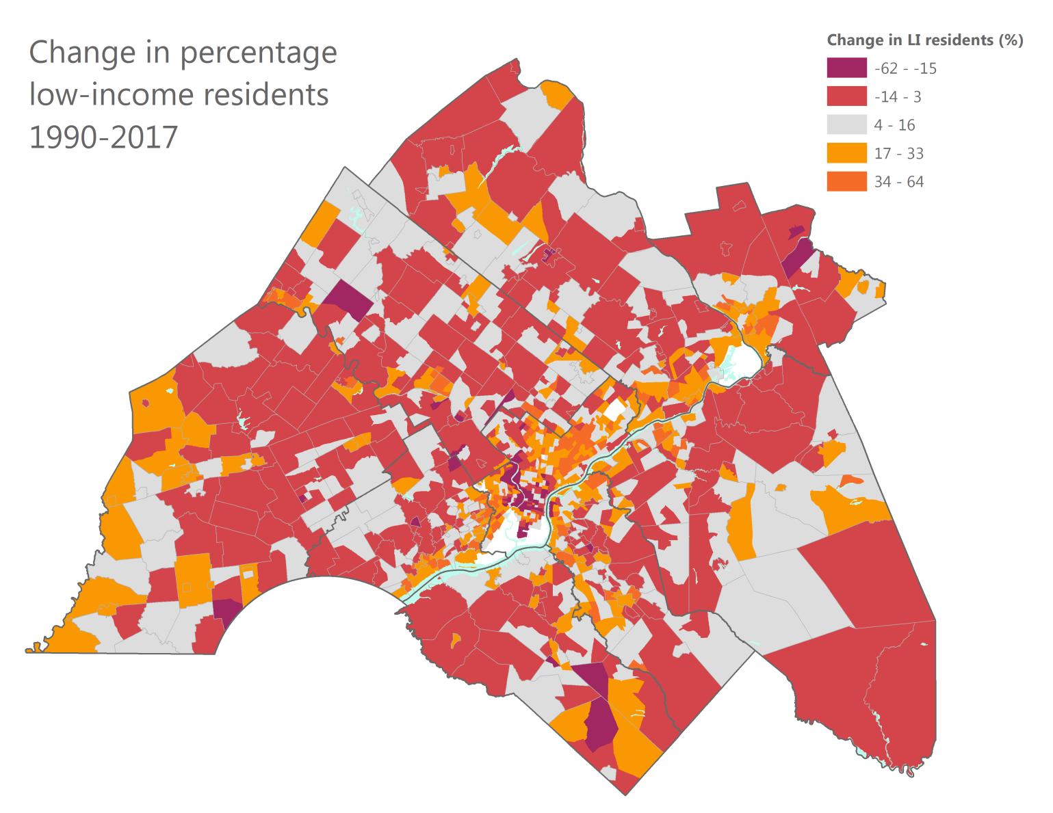

# Low-income residents live increasingly farther from Center City Philadelphia.

The two charts below show neighborhoods by the concentration of low-income residents in 1990 and 2017 and their distance to Philadelphia City Hall. In 1990, nearly 90% of neighborhoods with more than 60% low-income residents were located within 5 miles of City Hall. Today, that percentage has dropped from nearly 90% to 50%. Meanwhile, we see a substantial increase in concentrated low-income neighborhoods located 6-15 miles from City Hall, and more neighborhoods with few low-income residents located within 5 miles of City Hall.

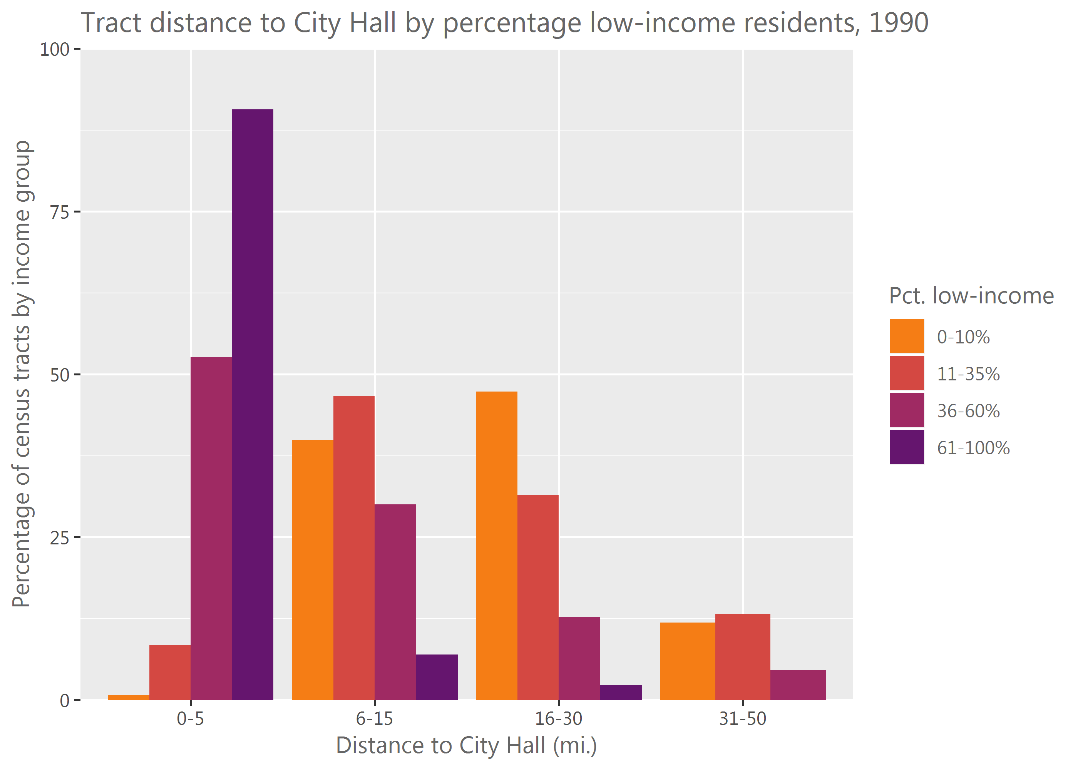

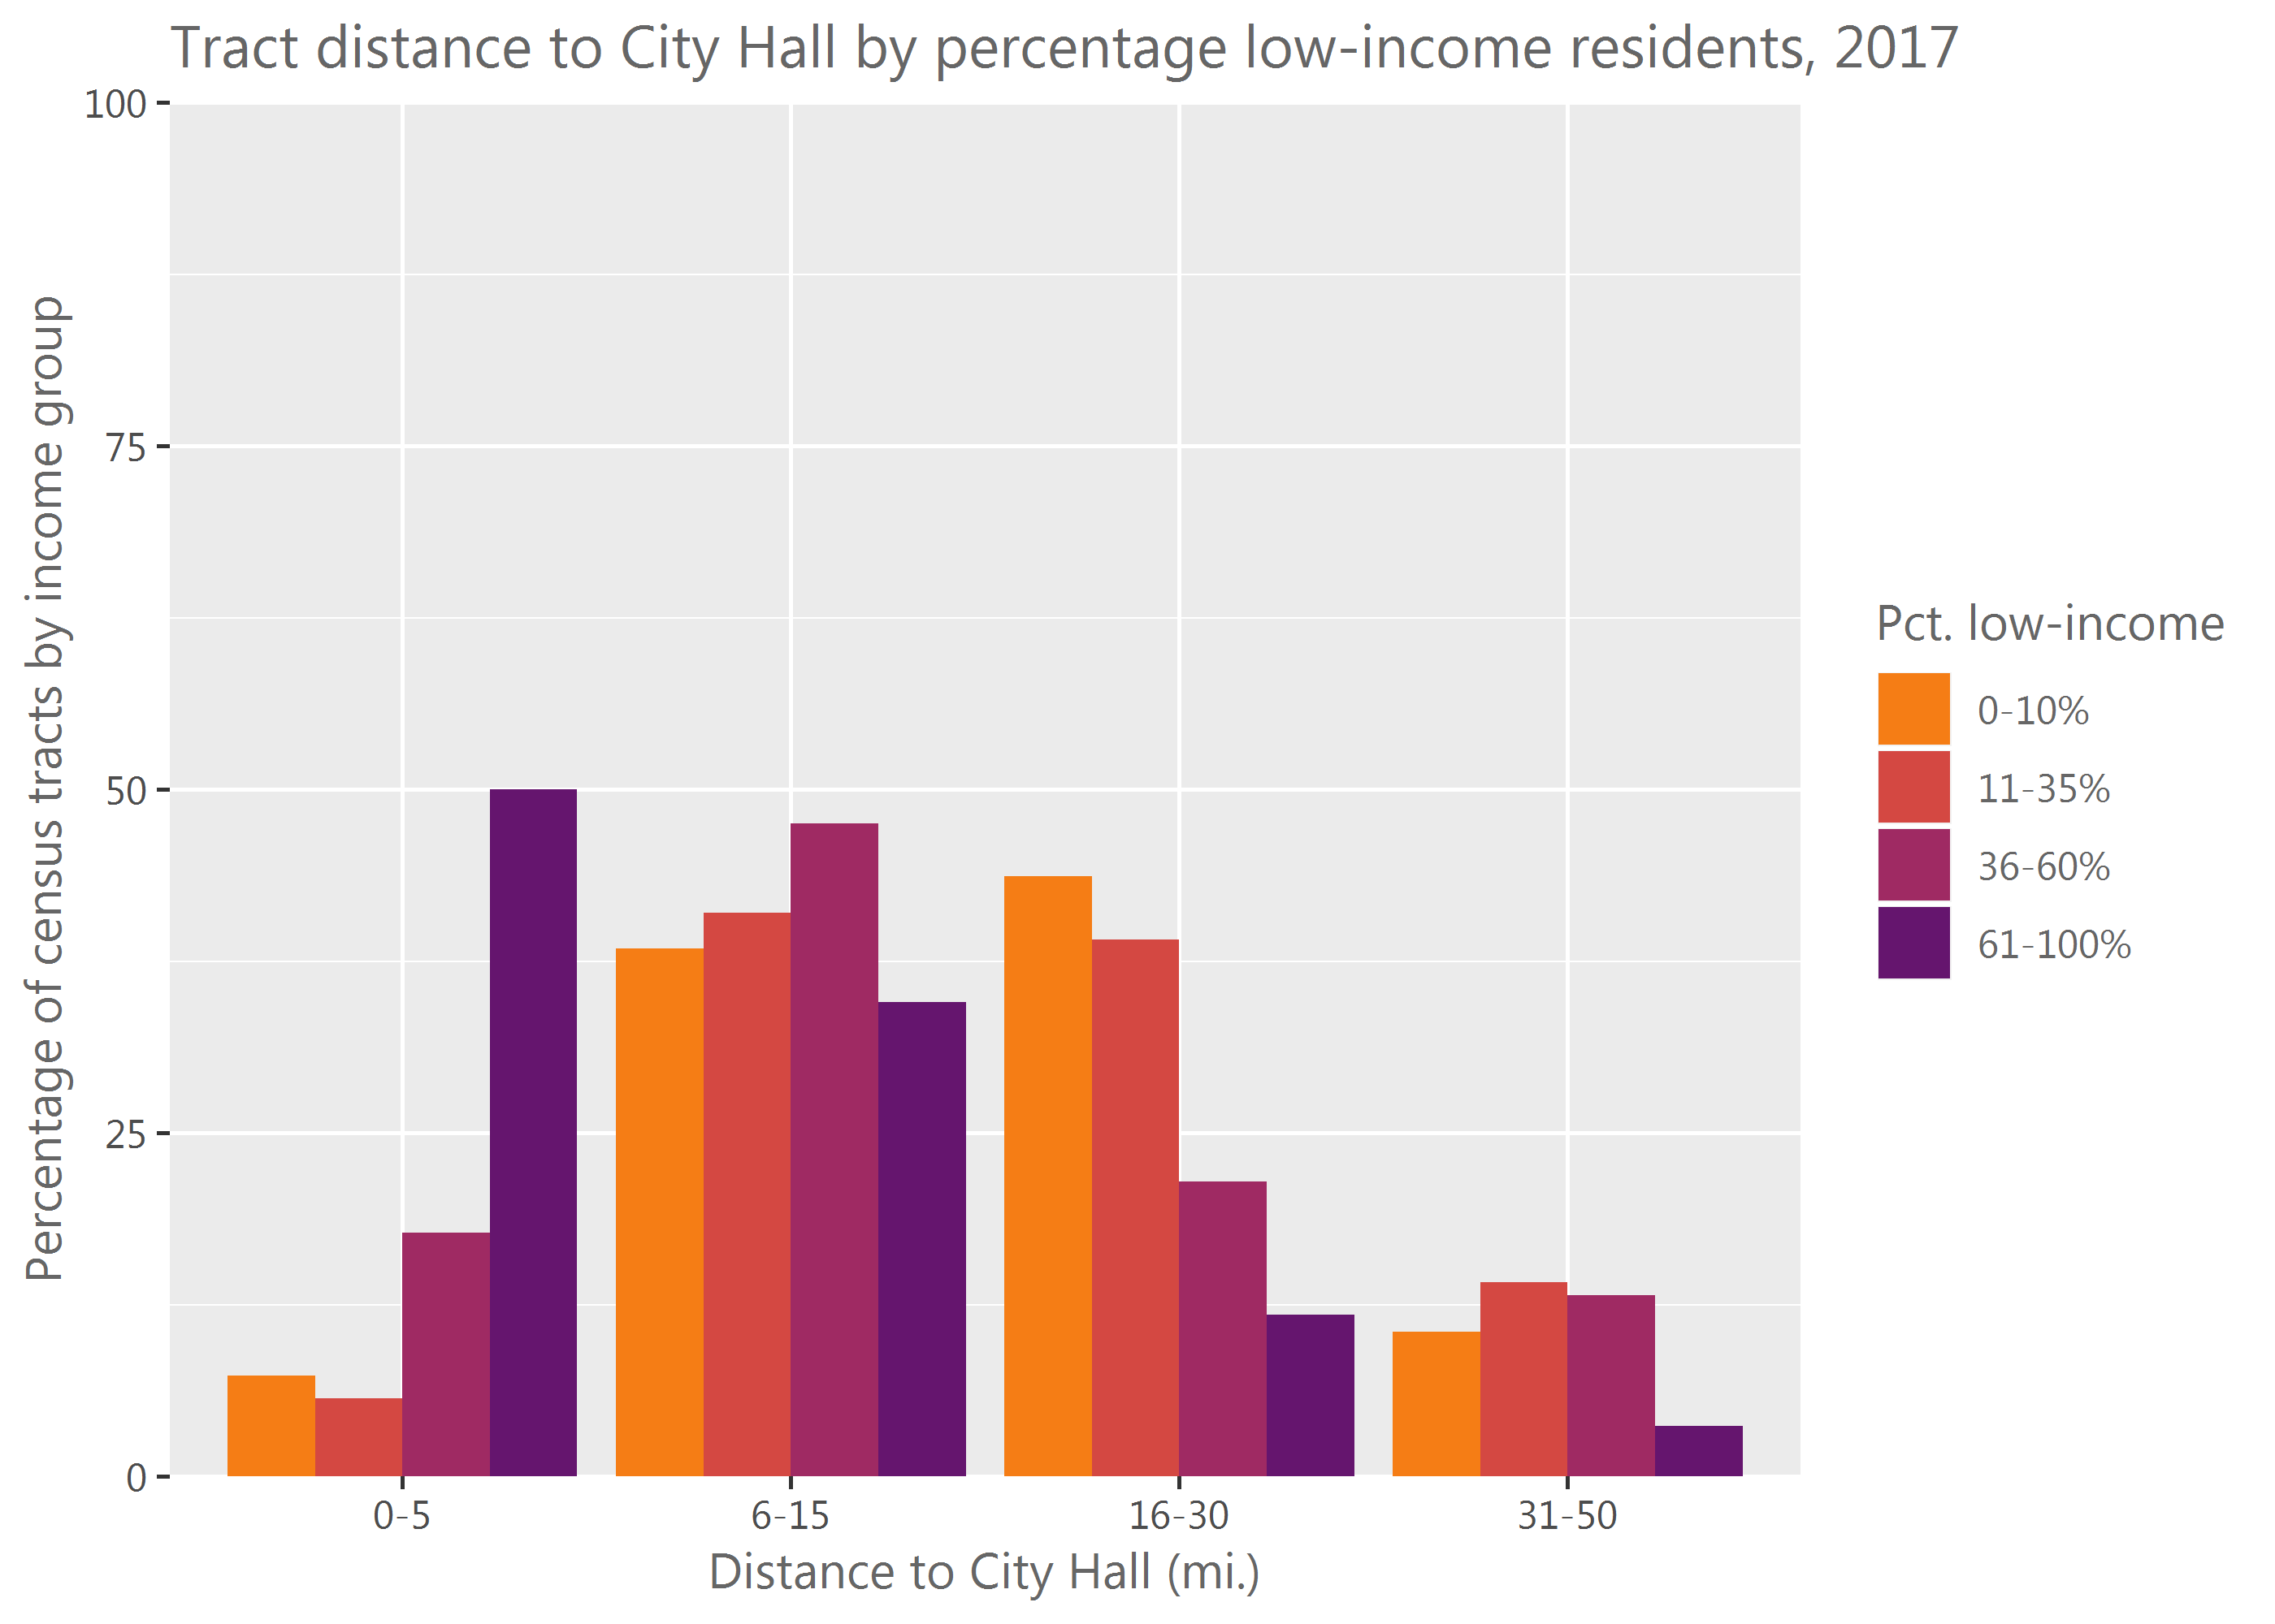

One of the largest drivers of the above trends appears to happen at the neighborhood level in Philadelphia. Between 1990 and 2017, neighborhoods in Center City, Spring Garden, and Fairmount have seen decreases in low-income residents while much of North and Northeast Philadelphia have seen substantial increases. In effect, low-income residents are moving from centrally-located Philadelphia neighborhoods to those located slightly farther from the city center.

# Home values are increasing in transit-accessible suburbs and in some Philadelphia neighborhoods.

Areas along the Main Line, including Radnor Township in Delaware County; and parts of Easttown, Willistown, East Goshen, Schuylkill, Newlin, and West Marlborough Townships in Chester County, have had a spike in home values from 1990 to 2017. In addition, Haddonfield Borough in Camden County has seen a similar increase in home value. In Philadelphia, neighborhoods with rising home values include Fairmount, Firlet Square, Graduate Hospital, Queen Village, Northern Liberties, Fishtown, Kensington, Chestnut Hill, and Spruce Hill.

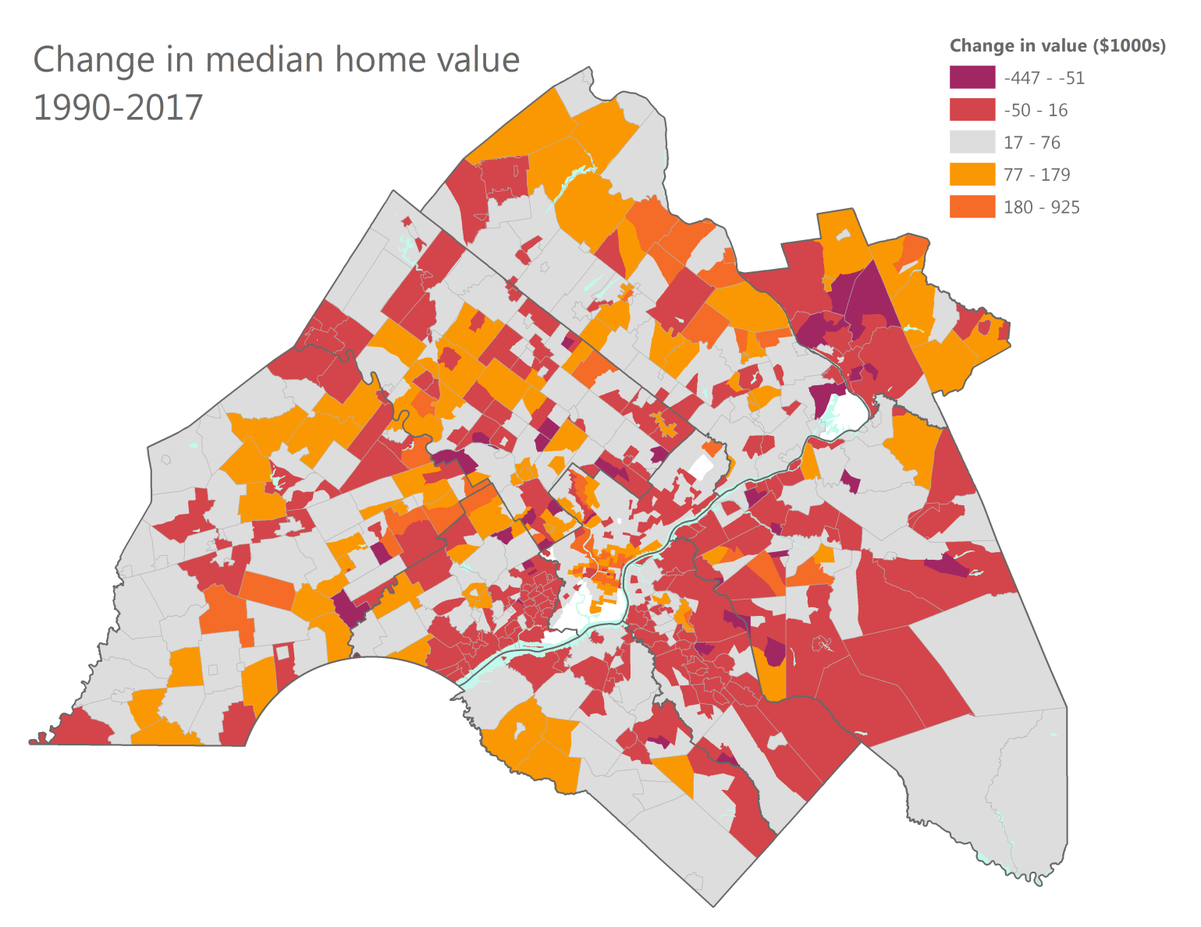

# Homeownership is falling rapidly in Philadelphia.

No other county shows the precipitous decline in homeownership. Since an occupied housing unit can either be owned or rented, the other way to phrase this is that the percentage of renters is rising rapidly in Philadelphia.

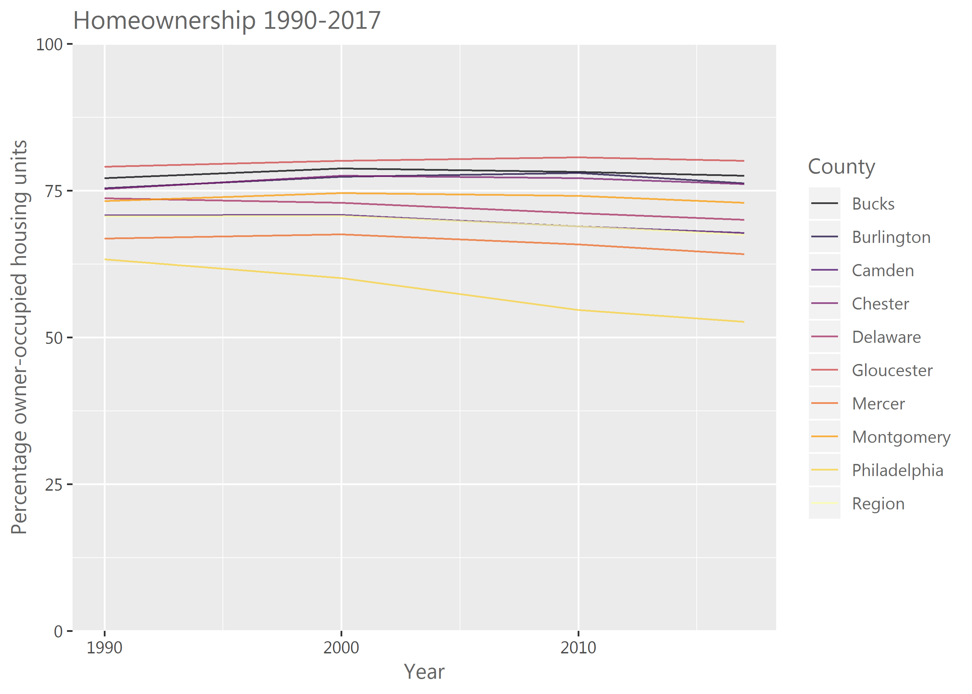

Here are the places where homeownership is falling: Cobbs Creek, Grays Ferry, Point Breeze, West Passyunk, Port Richmond, Frankford, Tacony, Germantown, and Manayunk. It is rising in Chestnut Hill, Roxborough, parts of Center City, and Old City.

